**Software Requirement Specification**

**For**

**Scenery Frame reservation service**

**Rajapakshe Garden**

**NEKFA AUSTRLIA (PVT) LTD**

4th Floor, 131, W A D Ramanayake Mawatha, Colombo 02

Tel: 011 2375062| email: info@nekfa.com

www.nekfa.com

|  |  |
| --- | --- |
| Deliverable | Software Requirement Specification- Scenery Frame reservation |
| Deliverable Date |  |
| Client | Negombo Municipal Council |

**Document Acceptance**

NEKFA Australia (PVT) LTD

|  |  |
| --- | --- |
| Name and Designation | Signature |
|  |  |
|  |  |

Document Amendment Register

|  |  |  |
| --- | --- | --- |
| Date | Author | Reviewer |
|  |  |  |
|  |  |  |

**Table of content**

**1. Introduction**

1.1 Purpose -------------------------------------------------------------------------- 6

1.2 Intendant Audience and users -------------------------------------------------------- 6

1.3 Scope of Project ----------------------------------------------------------------- 6

1.4 References -------------------------------------------------------------------------- 6

**2. Overall description**

2.1 Product Perspective ----------------------------------------------------------------- 7

2.2 User classes and characteristics ----------------------------------------------- 7

2.3 Operating Environment -------------------------------------------------------- 7

2.4 Product Features ----------------------------------------------------------------- 7

**3. System Features**

**3.1 request reservation**

3.1.1Flow chart ----------------------------------------------------------------- 8

3.1.2 Description ----------------------------------------------------------------- 8

3.1.3 Stimulus/Responses -------------------------------------------------------- 10

3.1.4 Functional requirements -------------------------------------------------------- 11

**3.2 pay for reservation**

3.2.1 Flow chart ----------------------------------------------------------------- 11

3.2.2 Description ----------------------------------------------------------------- 12

3.2.3 Stimulus/Responses -------------------------------------------------------- 12

3.2.4 Functional requirements -------------------------------------------------------- 13

**3.3 View rejected reservation details**

3.3.1 Flow chart ----------------------------------------------------------------- 14

3.3.2 Description ----------------------------------------------------------------- 14

3.3.3 Stimulus/Responses -------------------------------------------------------- 15

3.3.4 Functional requirements -------------------------------------------------------- 15

**3.4 View paid reservation details**

3.4.1 Flow chart ----------------------------------------------------------------- 15

3.4.2 Description ----------------------------------------------------------------- 16

3.4.3 Stimulus/Responses -------------------------------------------------------- 16

3.4.4 Functional requirements -------------------------------------------------------- 16

**3.5 View request list details**

**3**.5.1 Flow chart -------------------------------------------------------------------------- 17

3.5.2 Description ----------------------------------------------------------------- 17

3.5.3 Stimulus/Responses -------------------------------------------------------- 18

3.5.4 Functional requirements -------------------------------------------------------- 18

**3.6 Admin update payment.**

3.6.1 Flow chart -------------------------------------------------------------------------- 19

3.6.2 Description ----------------------------------------------------------------- 19

3.6.3 Stimulus/Responses -------------------------------------------------------- 20

3.6.4 Functional requirements -------------------------------------------------------- 20

* 1. **View approved request details**

3.7.1 Flow chart -------------------------------------------------------------------------- 21

3.7.2 Description ----------------------------------------------------------------- 21

3.7.3 Stimulus/Responses -------------------------------------------------------- 21

3.7.4 Functional requirements -------------------------------------------------------- 22

**3.8 View paid list details**

3.8.1 Flow chart -------------------------------------------------------------------------- 22

3.8.2 Description ----------------------------------------------------------------- 23

3.8.3 Stimulus/Responses -------------------------------------------------------- 23

3.8.4 Functional requirements -------------------------------------------------------- 23

**3.9 View rejected list details**

3.9.1 Flow chart -------------------------------------------------------------------------- 24

3.9.2 Description ----------------------------------------------------------------- 24

3.9.3 Stimulus/Responses -------------------------------------------------------- 24

3.9.4 Functional requirements -------------------------------------------------------- 24

**4. External interface requirement -----------------------------------------------** 25

**5. Non –Functional Requirement -----------------------------------------------** 56

**Appendix A** – Analysis models

1. Use case diagram ----------------------------------------------------------------- 27

**Annexures**

**Flow chart**

*Figure -1: My list overview ------------------------------------------------------ 28*

*Figure -2: Application for reservation --------------------------------------------- 28*

*Figure -3: Application for reservation --------------------------------------------- 29*

*Figure -4: Application for reservation --------------------------------------------- 29*

Figure -5: Submitted reservation request ------------------------------------ 30

*Figure -6: Approved request customer view ------------------------------------ 30*

Figure -7: Make payment ------------------------------------------------------ 31

*Figure -8: Rejected reservation request ------------------------------------ 31*

*Figure -9: Admin dash board ------------------------------------------------------ 32*

*Figure -10: Paid reservation request --------------------------------------------- 32*

*Figure -11: Requested application overview ------------------------------------ 33*

*Figure -12: Update Payment ------------------------------------------------------ 33*

1. **INTRODUCTION**

**1.1 PURPOSE**

This document describes the Software Requirements Specification for the Rajapakshe garden scenery frame Reservation. The purpose of this document is to provide guidelines for the development of the Garden scenery frame Reservation Portal.

**1.2 SCOPE OF THE PROJECT**

The Scope of this SRS document is to define the functional requirements for the Rajapakshe garden scenery frame reservation of Negombo municipal council and its component like User management. It also defines user interfaces, user characteristics, sitemaps, navigation, etc. for the portal.

It also covers non-functional requirements like performance, reliability, availability, security, maintainability, etc.

The proposed system will facilitate the introduction of a new solution that could enhance and improve the service standards offered to the customer. The purpose of this document is to provide guidelines for the development of the garden reservation system.

**1.3 INTENDANT AUDIENCE AND USERS**

This project is a prototype for the Scenery Frame reservation of the Rajapakshe garden online platform, where users can reserve the service online. This project needs to save customer-sensitive information and this has been implemented under the guidance of council members.

**1.4 REFERENCES**

1. **OVERALL DESCRIPTION**

**2.1 PRODUCT PERSPECTIVE**

The scenery frame Reservation service online platform of Rajapakshe garden is facilitate to user to apply for the reservation. Customer can fill application, Pay for the Reservation through online without entering the garden. Also admin can any time any ware approve and update the payment amount to the pay of Customer.

**2.2 USER CLASSES AND CHARACTERISTICS**

**Customer**

The customer is a user of the system who can request the reservation after filling out the reservation application and pay for the approved reservation using a debit or credit card through this online platform.

**Admin**

Admin is also a user of this platform and approves the customer application after reviewing the application details. Also, the admin can update the payment amount for the reservation. View Pending requests, Approved requests, Rejected requests, and Paid requests are functionality do by the admin.

**2.3 OPERATING ENVIRONMENT**

The entire set of applications is built on technologies to ensure product performance and durability. The following technologies and software are used to develop the application.

* OS –Windows
* Database – MYSQL
* Platform Language – HTML/CSS/JS/PHP/C#

1. **SYSTEM FEATURES**

**3.1 REQUEST RESERVATION**

**Scenario:** Request Reservation

**Actor:** Customer

**Precondition: 1.** User should have an internet connection

**3.1.1 Flow chart**

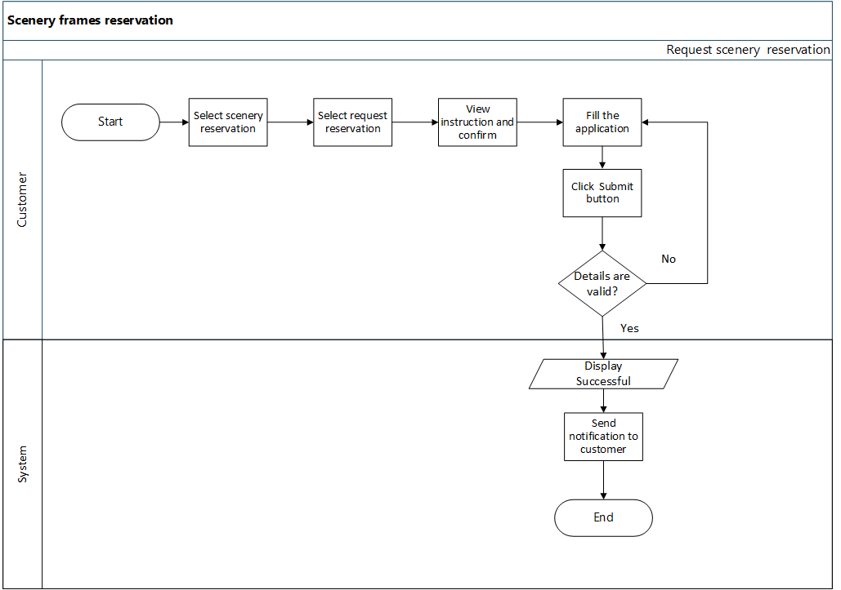

**3.1.2 Describe**

* Customer clicks the request reservation option and opens the application instruction page. This page has described the instruction for reservation and the system will facilitate the customer to confirm it*. (Refer :Figure1.Figure2, Figure3,Figure 4)*
* Then the customer is directed to the application page for the garden scenery frame reservation section. The following details are required and consist of the customer application.

|  |  |  |  |  |
| --- | --- | --- | --- | --- |
| **Field** | **Field Type** | **Length** | **Priority** | **Comment** |
| Applicant name | Text field | 50 | Mandatory | * Can be Alphanumeric, Alphabetic value |
| Applicant NIC | Text field | 10 | Mandatory | * Can be Alphanumeric, Alphabetic value * Validate NIC format |
| Applicant address | Text field | 100 | Mandatory | * Can be Alphanumeric, Alphabetic value |
| Applicant Mobile Number | Numeric | 10 | Mandatory | * Should auto-fill with the customer’s default phone number. * Should be a numeric value. * Show the tooltip. |
| Applicant Email | Text field |  | Optional | * Should validate the email address |
| Reservation date | Date/Time |  | Mandatory | * User shall be able to select multiple dates. * Use grid for show selected date and time from(am / pm) -To(related time for each selected date ) * Use the delete button to remove date by one inside the grid. * Use the “Confirm” button to the “add” button can add more dates. |
| Reservation Time |
| Reason | Text field | 225 | Mandatory | * User can describe the need for reason. (Text area) |
| Deposit amount | Numeric |  | Mandatory | * Should not be a null value for “Total deposit amount”. * Use the label or non-editable text field to show the calculation. |
| NIC upload |  |  | Mandatory | * “Upload “button can open file ------- can select png, jpeg, or PDF file types. |
| In the council | Drop down menu |  | Mandatory | * Use drop down |

* If the user selects more than one date according to each date user will be able to select the time duration for each date.
* After each field data is entered, the customer can Submit, Clear, or pending request list of the application.
* **Submit application**

The customer who filled out the application successfully can apply by clicking the “Submit” icon and before the application, the customer has to verify the submission (“Recaptcha”). When submit completed the system will notification to the admin or admin’s dashboard at that time and submitted completed, the system is required to send an acknowledgment SMS notification to the customer.

* **Clear Application.**

If the customer wants to clear the filled details the in the application customer can click the “Clear” icon.

* **Go Back**

If the customer clicks the “Back” button customer is directed to the user dashboard.

**Error flow.**

* If the user has not entered the required field data and submit, the system displays an error message for each field.
* User should have entered a valid NIC number.
* User should have entered a valid mobile number ex.07XXXXXXXX.

**3.1.3 Stimulus/ Responses**

**1. Stimulus**: The user clicks the scenery reservation option.

**Response:** The system displays the user dashboard.

**2. Stimulus:** The user clicks the request reservation option.

**Response:** The system displays an instruction page.

**3. Stimulus:** The user views the instruction and clicks confirm check box.

**Response:** The system display “Application for Scenery Reservation”.

**4. Stimulus:** The user fills out the application form and clicks submit icon.

**Response:** The system displays a “Successful” notification, Send a notification to the admin as a new request and receive a notification to the customer’s mobile phone as to the successful submission of the application.

**5. Stimulus:** If the user fills out the application and clicks the clear icon.

**Response:** The system displays the empty input field with the application.

**6. Stimulus:** If the user fills out the application and clicks the Back button.

**Response:** The system is direct to the customer dashboard.

**3.1.4 Functional requirements**

**REQ - 1:** Customer shall be able to view instructions.

**REQ - 2:** Customer shall be able to fill out the application.

**REQ - 3:** Customer shall be able to apply reservation.

**REQ - 4:** Customer shall be able to clear the application.

**REQ - 5:** Customer shall be able to go back to the customer dashboard.

**REQ - 6:** The system shall be able to send a notification to the customer.

**3.2 PAY FOR RESERVATION**

**Scenario** Pay for reservation

**Actor** Customer

**Precondition 1.** The user should have an internet connection

**2.** User should have submitted the application

**3.** Admin should have approved the payment.

**4.** Admin should have updated the payment

In this scenario, the user can pay for reservation service after being approved by the admin**.**

**3.2.1 Flow chart**

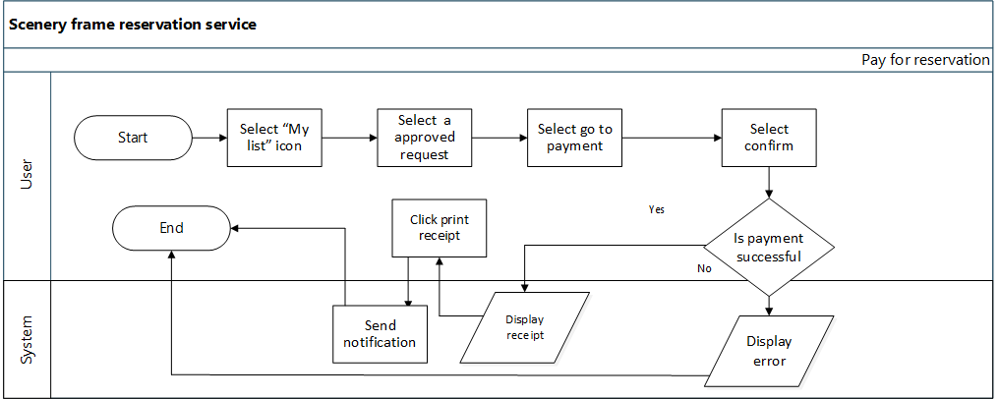

**3.2.2 Description**

After the admin approved and updated the payment user can pay for the reservation (*Figure 1*, *Figure 6*). The customer clicks the confirm pay and pays the total amount using a debit or credit card. *(Figure 7*)

When the payment is successful customer can print the receipt and also at the same time system send the notification to the customer.

**The following details are included in the receipt.**

* Oder id(Auto-generated)
* Applicant Name
* Pay date
* Total fee
* Bank fee
* Total paid amount
* Pay by
* Reference Number

**The following details consist of the approved details from view.**

* Applicant name
* Deposit Amount
* Applicant’s address
* Applicant’s mobile number
* Applicant’s NIC
* Park
* Requested dates
* In the council

**3.2.3 Stimulus/ Response**

**1. Stimulus:** The user selects the “My list” option.

**Response:** The system display list of request.

**2. Stimulus:** The user clicks admin-approved request details.

**Response:** The system displays an overview of approved details.

3. **Stimulus:** The user clicks the Go to pay button.

**Response:** The system displays a description of payment.

**4. Stimulus:** The user clicks the confirm button.

**Response:** System check payment success or unsuccessful.

**5. Stimulus:** If the successful user clicks the receipt print button.

**Response:** The system displays the option to print the receipt.

**6. Stimulus:** The user clicks the Back button.

**Response:** The system goes to the My list page.

**Error flow**

* If payment is unsuccessful system display an error message.

**3.2.4 Functional Requirement**

**REQ-1:** The user shall be able to view **payment-approved details for the reservation service.**

**REQ-2: The user shall be able to make a payment.**

**REQ-3: The user shall be able to confirm payment.**

**REQ-4: The user shall be able to print payments.**

**REQ-5: System shall be able to send notifications to customers.**

**3.3 VIEW REJECTED RESERVATION DETAILS**

**Scenario**  Customer views rejected reservation details.

**Actor**  Customer

**Precondition:** **1**. User should have a web browser.

**2**. User should have an internet connection.

**3.** User should have requested reservation service.

**4.** Admin should have rejected the reservation.

**3.3.1 Flow chart**

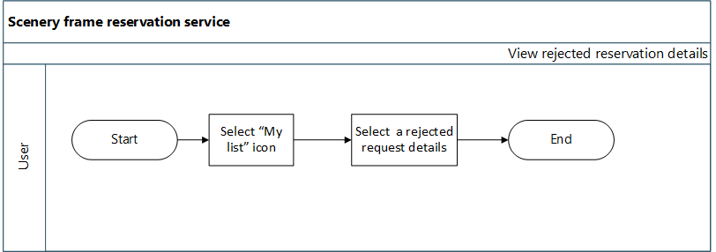

**3.3.2 Description**

When admin rejected the customer request the customer can view details of the reason for rejection also system not will give the option for payment furthermore. *(Figure 8)*The following details are included in the customer-rejected view.

* Applicant name
* Applicant’s address
* Applicant’s mobile number
* Applicant’s NIC
* Park
* requested dates
* Deposit Amount

**Error flow**

* The system displays an error message if the admin has not approved (rejected).

**3.3.3 Stimulus/ Responses**

1. **Stimulus:** The user selects a rejected request option.

**Response:** The system displays details of rejection.

**3.3.4 Functional Requirement**

**REQ-1:** The user shall be able to view the request list.

**REQ-2:** The user shall be able to view rejected reservation details.

**REQ-3:** The user shall not be able to give the option to the customer to update payment.

**3.4 VIEW PAID RESERVATION DETAILS**

**Scenario**  Customer views paid reservation details.

**Actor**  Customer

**Precondition:** **1**. User should have a web browser.

**2**. User should have an internet connection.

**3.** User should have requested reservation service.

**4**. Admin should have approved the reservation.

**5.** User should have paid for the reservation.

**3.4.1 Flow chart**

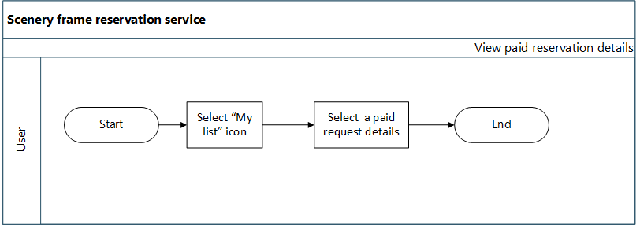

**3.4.2 Description**

When the customer paid the payment for a reservation the details are viewed in the paid list view*. (Figure 9)*

* Applicant name
* Applicant’s address
* Applicant’s mobile number
* Applicant’s NIC
* Park
* requested dates
* Deposit Amount

**3.4.3 Stimulus/ Responses**

**1. Stimulus:** The user selects paid request details.

**Response:** The system displays details of paid.

**3.4.4 Functional Requirement**

**REQ-1:** The user shall be able to view the paid reservation details.

**3.5 VIEW REQUEST LIST DETAILS**

**Scenario** Admin views a pending reservation request list details.

**Actor** Admin

**Precondition 1**. The user should have a web browser.

**2**. User should have an internet connection.

**3.** User should have requested service.

**3.5.1 Flow chart**

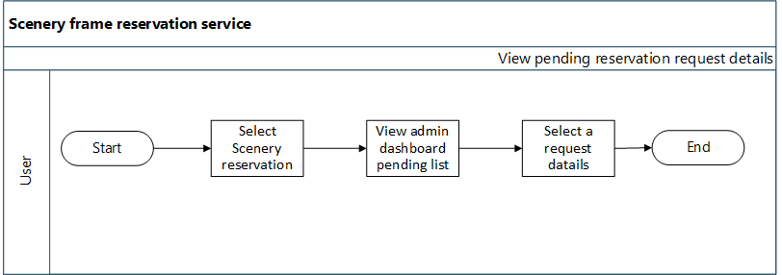

**3.5.2 Description**

After the customer request the reservation, the admin can view that details through pending request details. The system displays the requested details of the applicant. So the system allows to admin to download attachments, go back to the pending details page of the admin dashboard view, and print details options. After validating the request details admin can approve or reject the requested service. Also, the system sends messages to users through mobile numbers or email states of rejection or approval*. (Figure 10, figure 11)*

Admin should be able to do the following functionality

* Download and view the NIC copy.
* Back
* Print request details
* Approve
* Reject

**3.5.3 Stimulate/response**

1. **Stimulus:** Admin clicks pending request details.

**Response:** The system display request details and history details.

**2. Stimulus:** Admin clicks the download icon.

**Response:** The system display gives the option to the download attachment.

**3. Stimulus:** Admin clicks the print button.

**Response:** The system operates the print option.

**4. Stimulus:** Admin clicks the back button.

**Response:** System direct request pending list overview.

**5. Stimulus:** Admin click approves button.

**Response:**  The system displays an updated payment form. (Explained in update payment)

**6. Stimulus:** Admin clicks the rejects button.

**Response:** The system updates the request into rejected list overview and sends a message to the Customer.

**3.5.4 Functional Requirement**

**REQ-1:** Admin shall be able to view pending request list details.

**REQ-2:** Admin shall be able to download and view NIC copy

**REQ-4:** Admin shall be able to go back pending request details.

**REQ-5:** Admin shall be able to print request details.

**REQ-6:** Admin shall be able to approve the valid request.

**REQ-7:** Admin shall be able to reject the invalid request.

**REQ-8:** System shall be able to send notifications to the user, and states of request approval or rejection.

**3.6 ADMIN UPDATE PAYMENT.**

**Scenario** Admin update payment.

**Actor** Admin

**Precondition 1.** Admin should have an internet connection.

**2**. User should have requested service.

**3**. Admin should have approved the request.

**3.6.1 Flow chart**

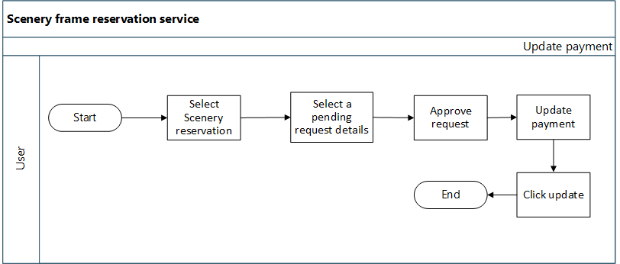

**3.6.2 Description**

After the admin approved the application, the system displays the updated payment view. After the update, the total amount system will send a notification to the customer and the updated request move into the approved list view. The following details include the approve request page. (*Figure 12*)

* Requested Date/Dates
* List of selected dates and times.
* In the council?
* Payment Due date (admin can select a date using calendar)
* Deposit Amount
* 1st Date charge (default Rs.10000.00)
* Additional data charges should calculate for additional details. The additional charge for one day is rs.5000.00 (admin can enter the amount of additional payment)
* Total Deposit Amount (auto calculate the 1st Date charge + Additional data charges)
* Comments

**3.6.3 Stimulus/ Responses**

**1. Stimulus:** Admin enters the amount of additional date charge

**Response:** The system generates and displays the total deposit amount.

**2. Stimulus:** Admin enters the update button.

**Response:** System display notification state of update success.

**3. Stimulus:** If the user fills out the application and clicks the clear icon.

**Response:** The system displays the empty input field with the application.

**4. Stimulus:** If the user fills out the application and clicks the Back button.

**Response:** The system directs to the admin dashboard.

**3.6.4Functional requirements**

**REQ-1:** Admin shall be able to update payment.

**REQ-2:** Admin shall be able to add the due date.

**REQ-3:** Admin shall be able to select a due date.

**REQ-4:** system shall calculate additional data charges

**REQ-5:** admin shall able to edit additional charges

**REQ-6:** admin shall not be able to edit the total deposit amount

**REQ-7:** System shall be able to generate the total amount.

**REQ-8:** System shall be able to send notifications to the customer.

**3.7 VIEW APPROVED REQUEST DETAILS**

**Scenario** View approved request list details.

**Actor** Admin

**Precondition**  **1**. Admin should have an internet connection.

**2.** User should have requested service.

**3.** Admin should have approved the request.

**3.7.1Flowchart**

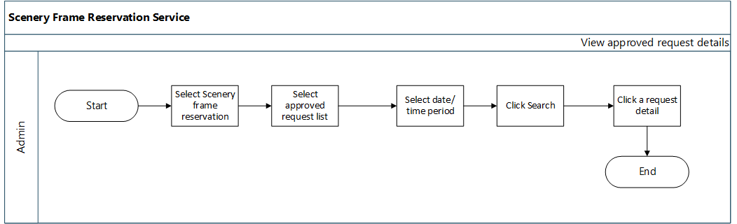

**3.7.2 Description**

After the approved reservation service request which request is moved into the approved request list view. Admin can select a particular period and search list according to that period. Also, the system fetches the resulting user search.

**3.7.3 Stimulus /Responses**

**1. Stimulus:** Admin selects scenery reservation.

**Response:** The system displays a dashboard overview of requesting list details.

**2. Stimulus:** Admin selects the approved list option.

**Response:** The system displays the list of approved.

**3. Stimulus:** Admin selects a particular time duration and searches.

**Response:** The system displays the calendar to select the date and the filter result is display the details in the view.

**3.7.4 Functional Requirements**

**REQ-1:** Admin shall be able to select the period for the filter list.

**REQ-2:** Admin shall be able to search a list of details in the selected period.

**REQ-3:** System shall be able to display a calendar to select dates.

**REQ-4:** System shall be able to fetch the approved requested details list according to the selected date.

* 1. **VIEW PAID LIST DETAILS**

**Scenario** View paid request details list

**Actor** Admin

**Precondition 1**. Admin should have an internet connection.

1. User should have requested a scenery frame reservation.

**3**. Admin should have approved user requests.

**4**. User should have paid for the service.

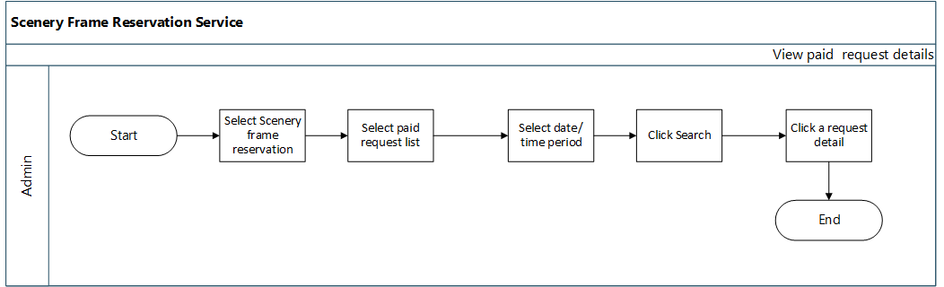**3.8.1 Flow chart**

**3.8.2 Description**

After the approved and updated payment request list details are moved into the paid request list. Admin can select a particular period and search list according to that period.

**3.8.3. Stimulus/Response**

**1. Stimulus:** Admin select paid request list icon.

**Response:** The system displays an overview of the paid request list.

1. **Stimulus:**  Admin selects period search.

**Response:** The system displays the calendar and fetches paid request list details to the view.

1. **Stimulus:** Admin selects a paid request.

**Response** System display details of paid list details.

**4. Stimulus:** Admin clicks the Back button.

**Response:** System direct cemetery request overview.

**3.8.4 Functional Requirement**

**REQ-1:** Admin shall be able to view paid request details.

**REQ-2:** Admin shall be able to go back cemetery service overview.

**REQ-3:** System shall be able to display a calendar to select dates.

**REQ-4:** System shall be able to fetch paid requested details list according to the selected date.

* 1. **VIEW REJECTED LIST DETAILS**

**Scenario** Admin view rejected request details.

**Actor** Admin

**Precondition 1**. Admin should have an internet connection.

**2.** User should have requested a Scenery reservation request.

**3**. Admin should have rejected the requested service.

**3.9.1 Flow chart**

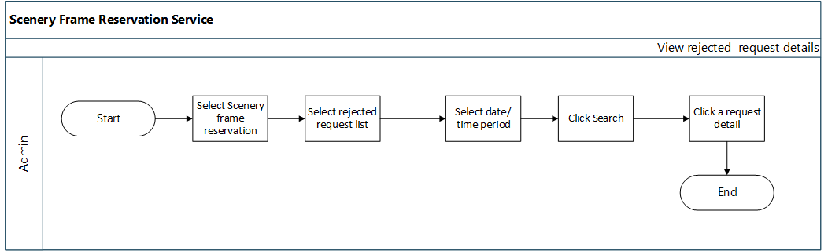

**3.9.2 Description**

After rejecting the request by admin that request move into the reject list section. Admin can select the date duration and the search system displays the rejected list details. Admin selects a request and who can view details overview of request details.

**3.9.3 Stimulus/Responses**

**1. Stimulus:** Admin select rejected request list icon.

**Response:** The system displays an overview of the rejected request list.

**2. Stimulus:**  Admin selects time period search.

**Response:** The system displays a calendar and fetches rejected request list details to the view.

**3. Stimulus:** Admin selects a rejected request.

**Response:** The system display details of rejected list details.

**4. Stimulus:** Admin clicks the Back button.

**Response:** System direct pending list page overview.

**3.9.4 Functional Requirement**

**REQ-1:** Admin shall be able to view rejected request list details.

**REQ-2**: Admin shall be able to select date duration and search.

**REQ-3:** Admin shall be able to view request details and history details.

**REQ-5:** Admin shall be able to print rejected request details.

**REQ-6:** Admin shall be able to go back cemetery service overview.

**REQ-7:** System shall be able to display a calendar to select dates.

**REQ-8:** System shall be able to fetch rejected requested details list according to the selected date.

1. **EXTERNAL INTERFACE REQUIREMENT**

**4.1 User Interfaces**

Web-based Graphical User Interface (GUI) will be provided. The Garden reservation Portal will be completely menu-driven and user-friendly. The Portal will be designed so that with the minimum number of clicks user should be able to access the desired information. Screens will be ergonomically designed. Wherever possible, input fields will be pre-selected.

Product function-wise user interfaces such as screen formats for Input forms, output screens, report layouts, and menu structures have been explained in subsequent sections.

**4.2 Hardware Interfaces**

Users of the Rajapaksha Garden Reservation Portal will be able to access it on their client systems, and smartphones.

To host the portal, hardware servers will be required for the Portal server (Content Management), Application Server, Database, and SMS server with adequate backup facilities and disaster recovery mechanism for 24 X 7 availability.

**4.3 Software Interfaces**

Users will be able to access the portal using a web browser on the system having a base Operating System. On the Server end, in addition to the base Operating system, the software will be required for the internet server, Content Management, and Database.

1. **NON-FUNCTIONAL REQUIREMENT**

**5.1 Software Systems Attributes**

**Availability**

Availability refers to a system or component that is continuously operational for a desirably long length of time. It is an ability to withstand the failure of individual components. The Central Agricultural portal should be highly available. To make the garden reservation solution to be highly available, all components like hardware, network, system software, and application software for the Garden reservation solution must be operational all the time. If the system is not available all the time, the user loses interest and avoids using the service again presuming that it may waste his/her time in accessing the service without any result.

**Scalability**

Scalability is the ability of a system, network, or process, to handle a growing amount of load capably using deploying additional resources, if required, without any noticeable degradation of its performance.

**Usability**

Usability is a quality attribute that assesses how easy user interfaces are to use. Compromising user friendliness leads to a loss of productivity. Garden Reservation Portal should be easy to use. The underlying technology should be transparent to users, so they can concentrate on the tasks at hand. Screens should be designed for ease of use by non-technical users who do not have any computer knowledge. The GUI design shall be intuitive and task-based without any superfluous design.

* 1. **Performance Requirements**

The system must be interactive, and the delays involved must be less. So, in every action response of the system, there are no immediate delays. The application shall be fast when loading. Also, when connecting to the database server, the wait to make a successful connection should be less for effective real-time communication. The cemetery service system shall handle expected and non-expected errors in ways that prevent loss of information and an extended downtime period.

**5.3. Safety Requirements**

The web application should be able to protect itself from any external danger or attacks.

* 1. **Security Requirements**

There is a need for proper and encrypted login authentication for users’ information should be protected from hacking. Information transmission should be securely transmitted to the database without any information changes. The database may crash anytime due to viruses or operating system failure. Therefore, it is required to take the database backup so that the database is not lost.

**Appendix A**

1. Use Case Diagram

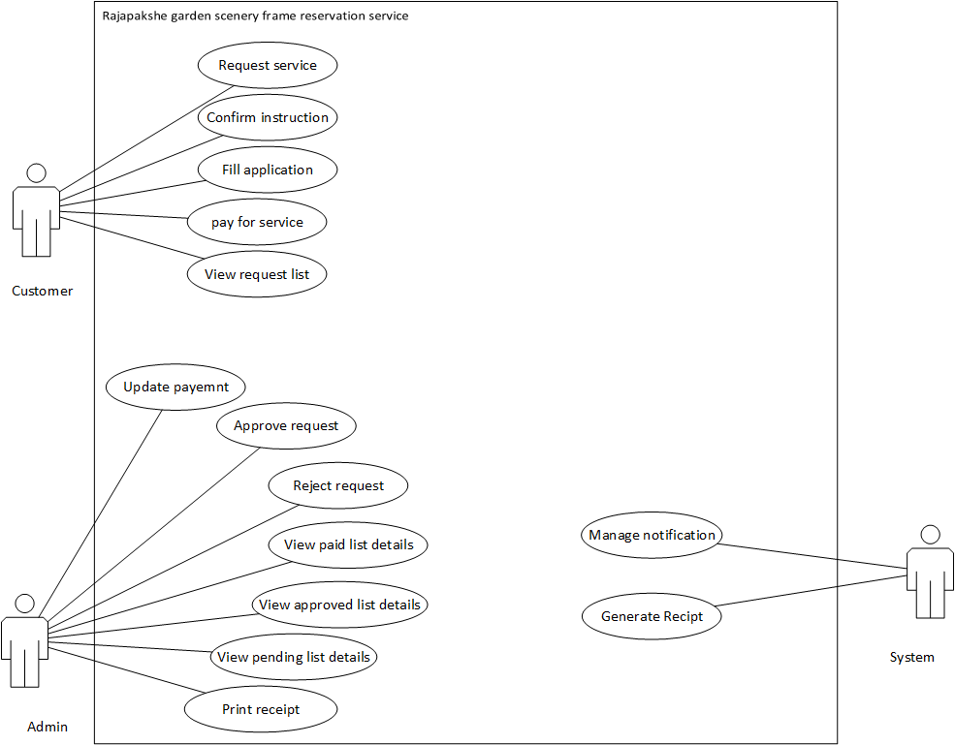

**Appendix** B

Wireframes:

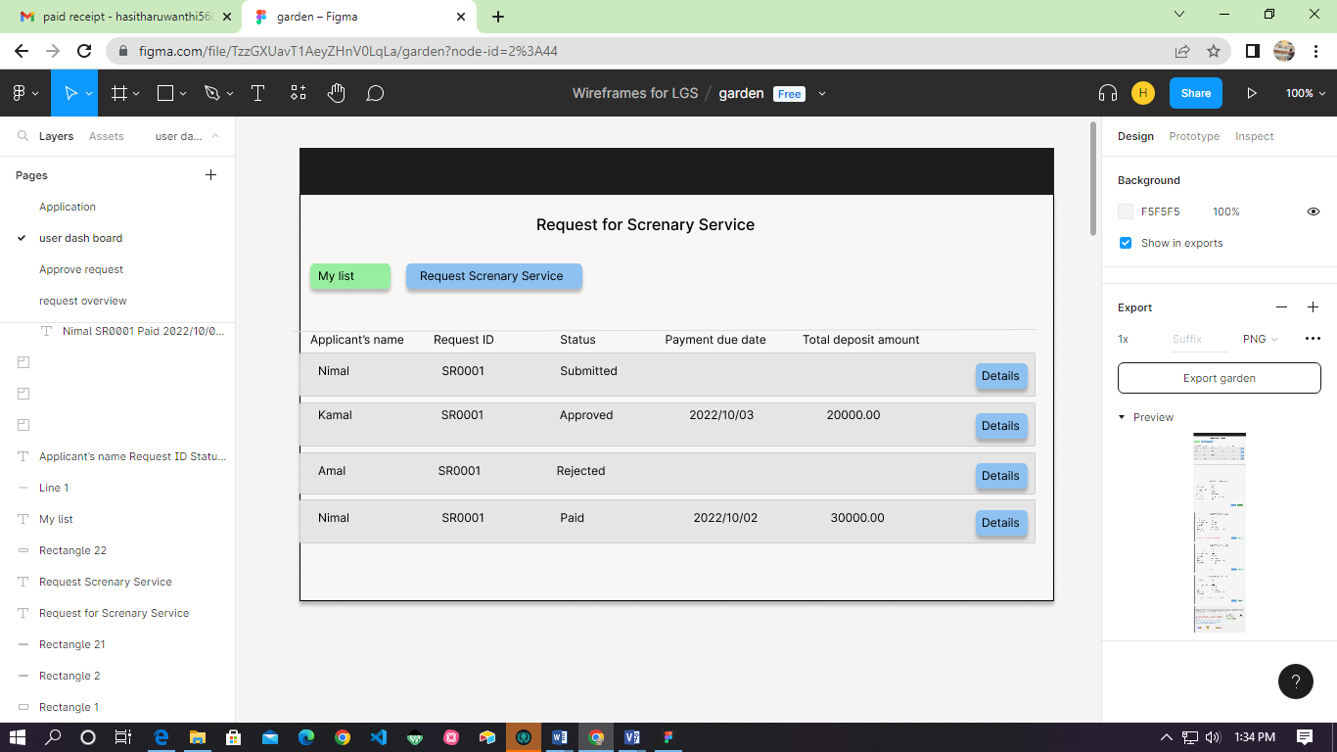

Figure 1-My list overview

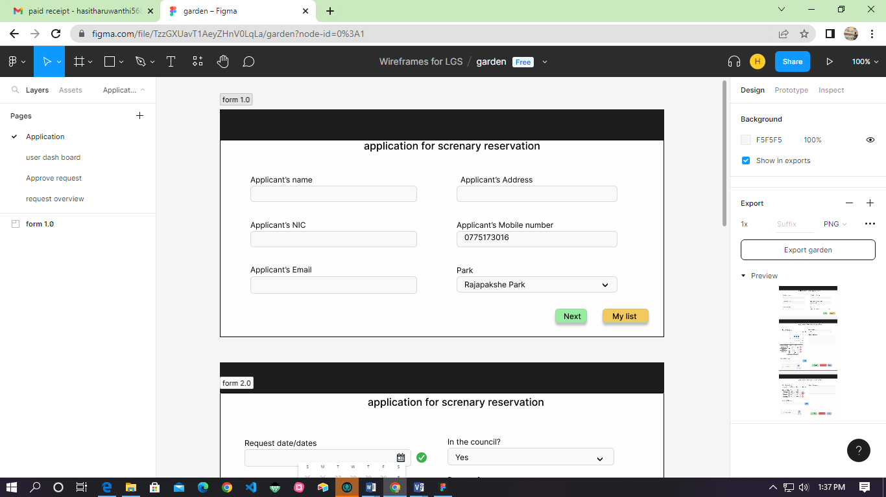

Figure 2-Application for reservation

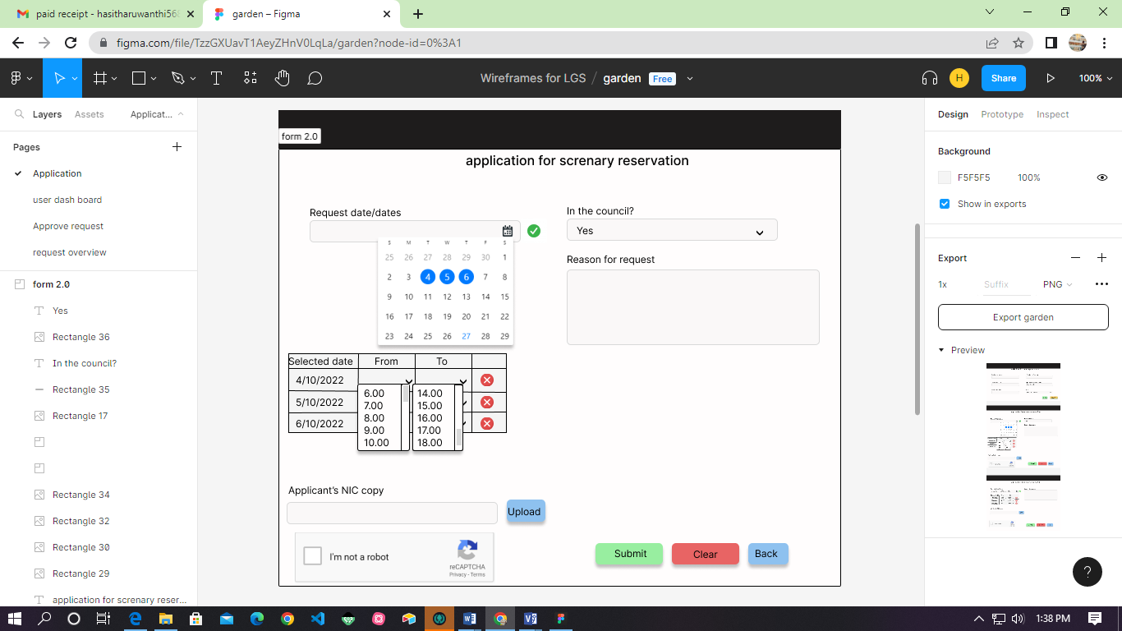

Figure 3- Application for reservation

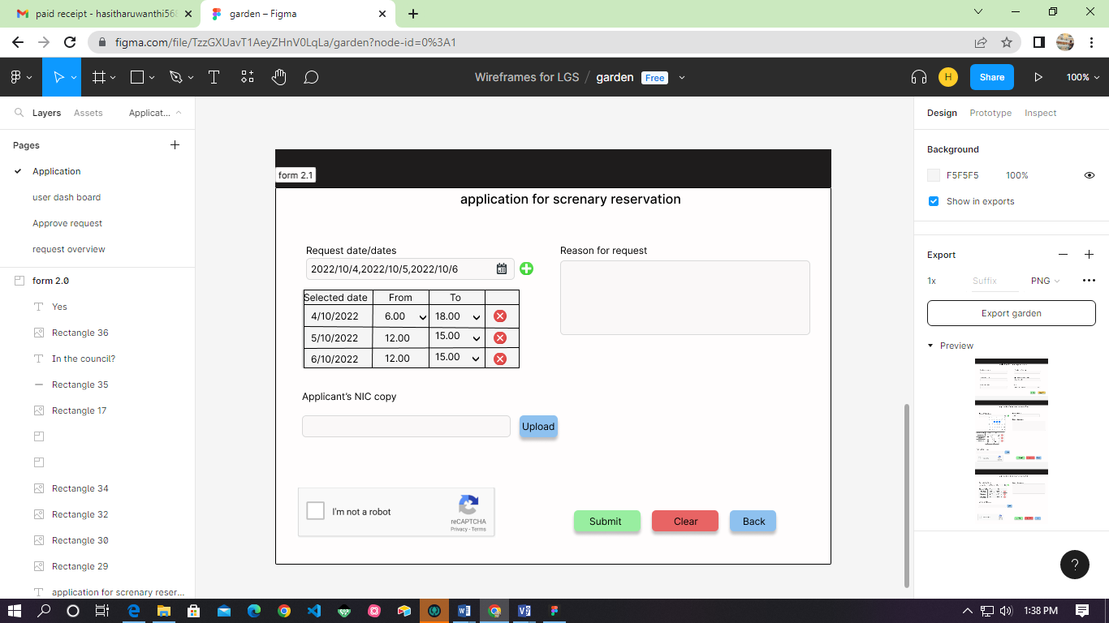

Figure 4- Application for reservation

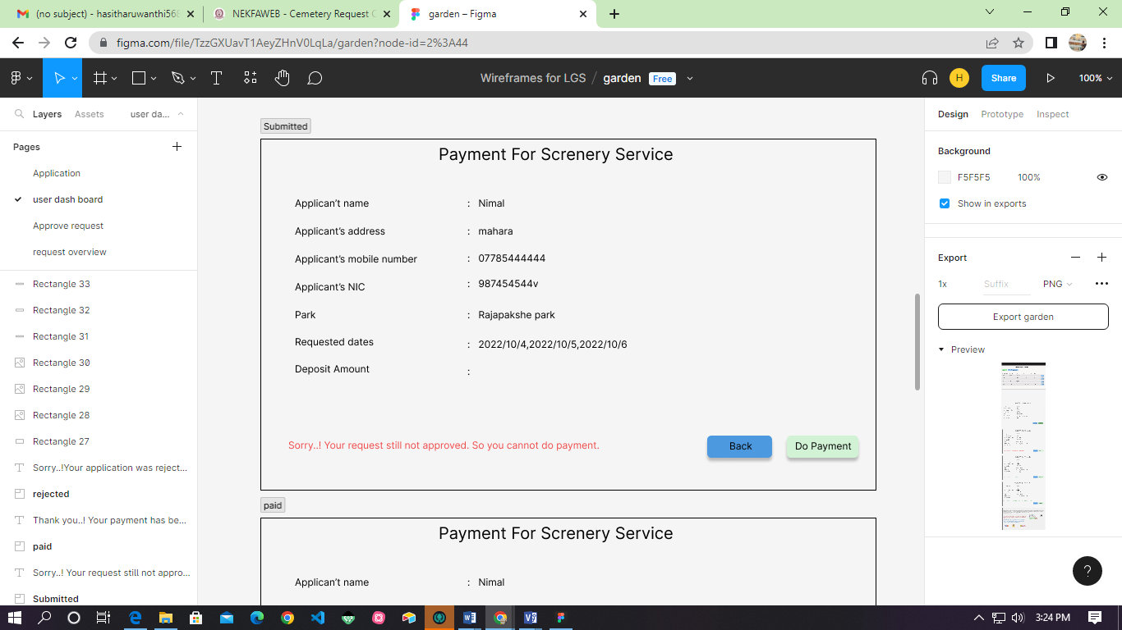

Figure 5- Submitted reservation request

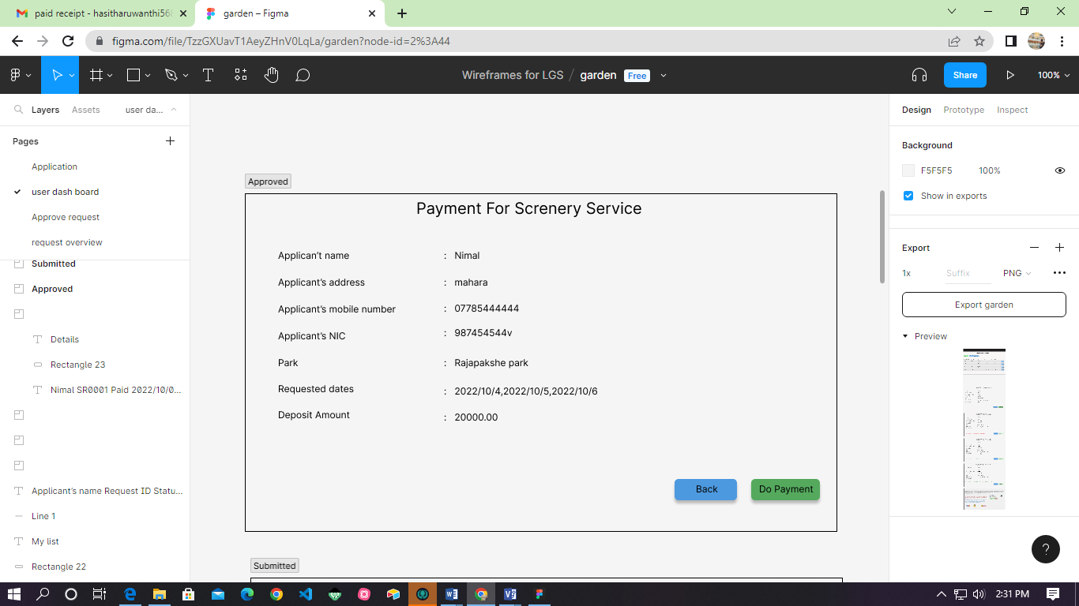

Figure 6-Approved request customer view

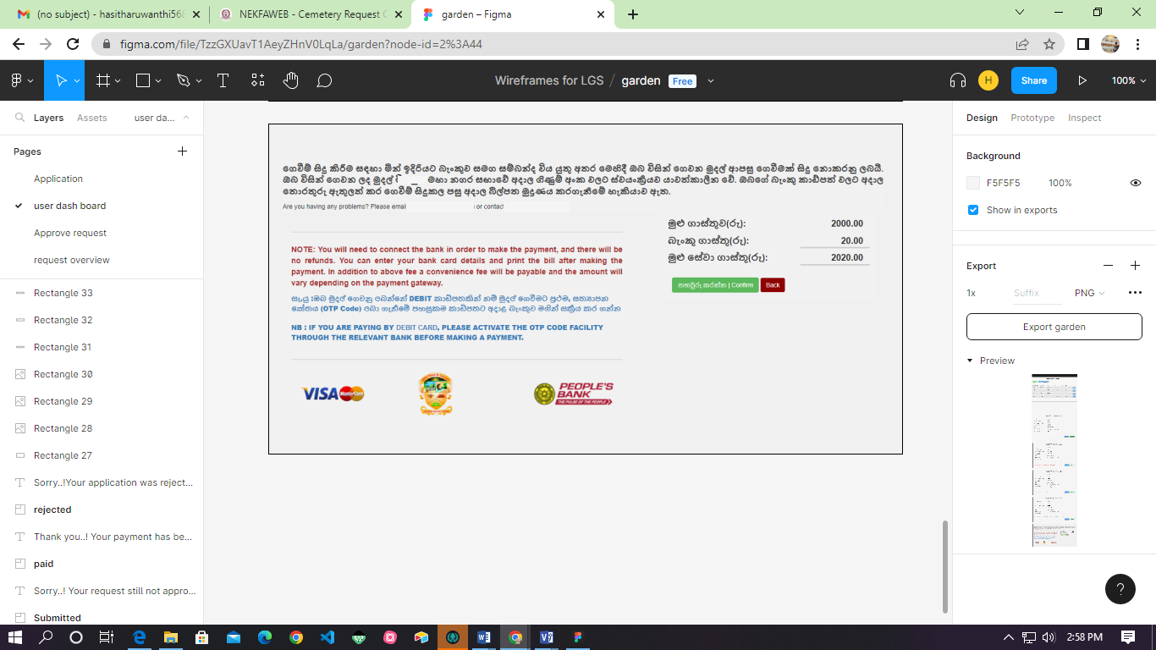

Figure 7-Make payment

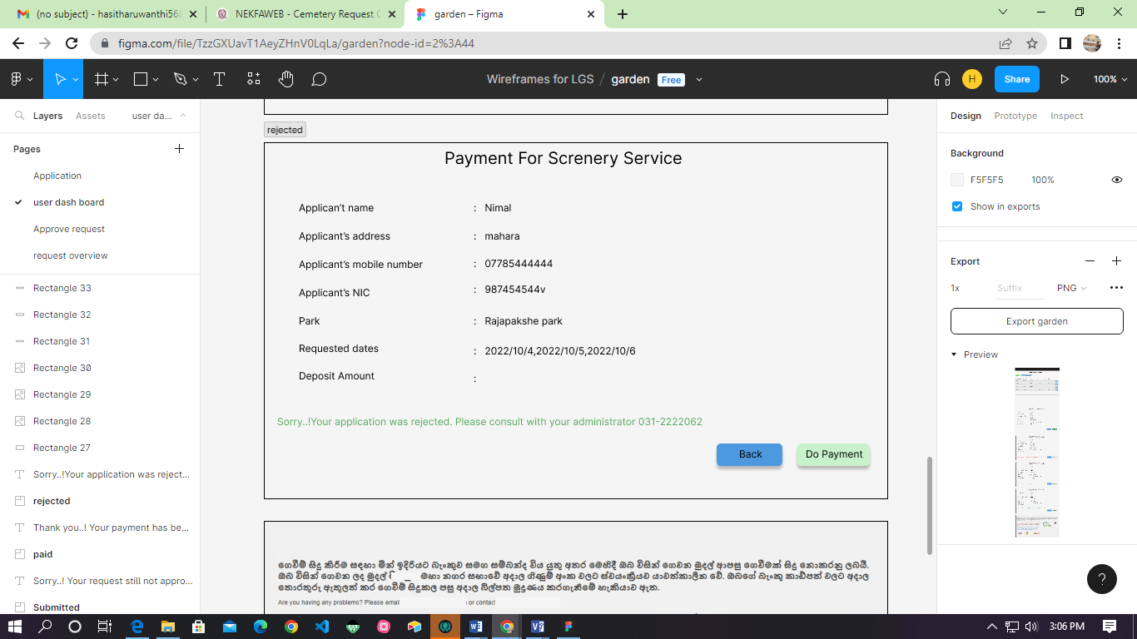

Figure 8-Rejected reservation request

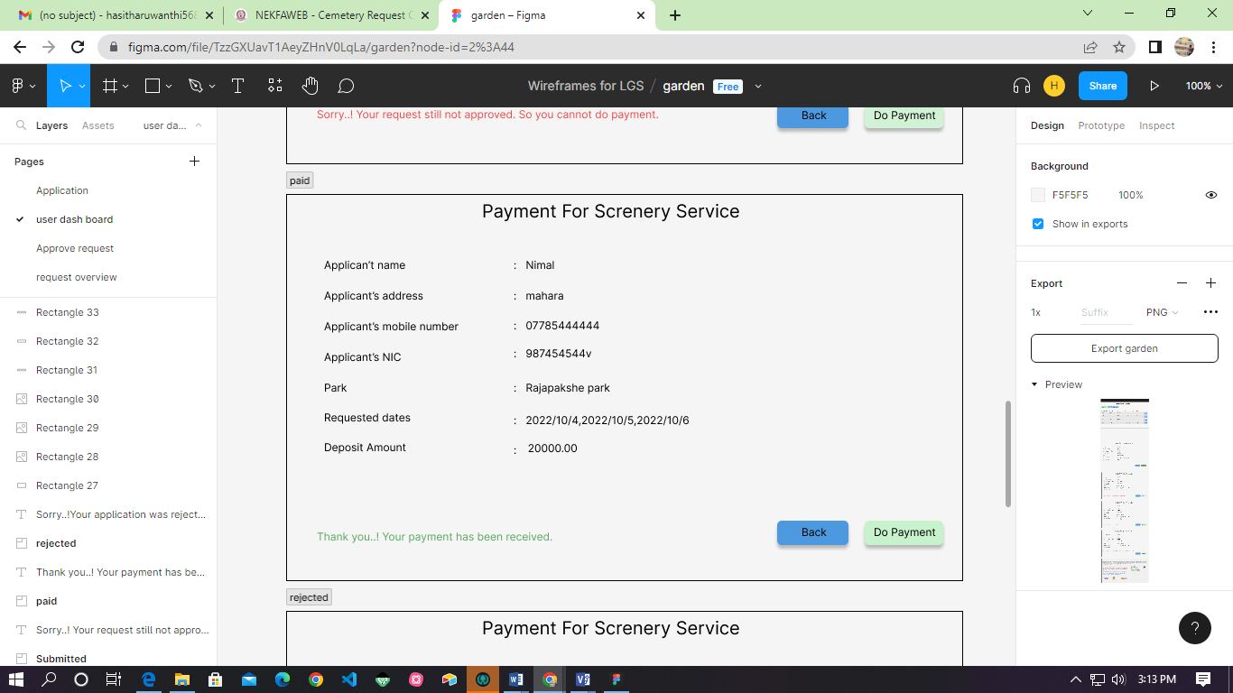

Figure 9- Paid reservation request

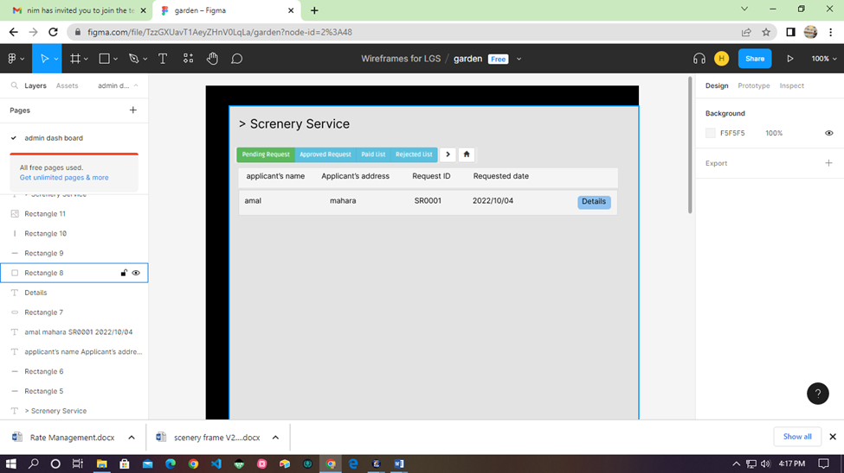

Figure 10-Admin dash board

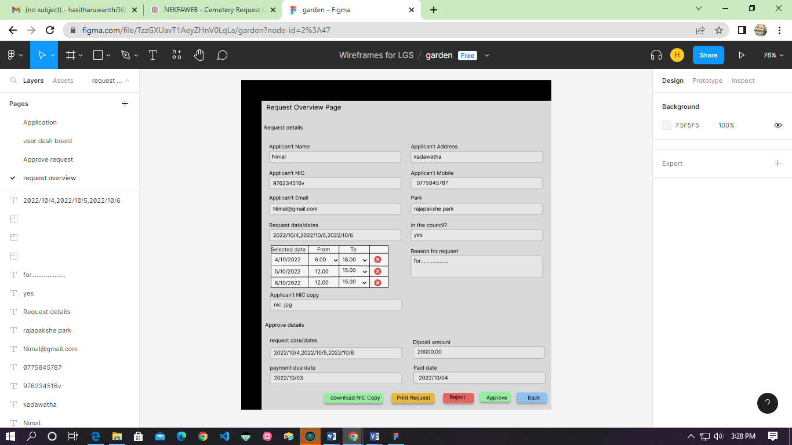

Figure 11-Requested application overview

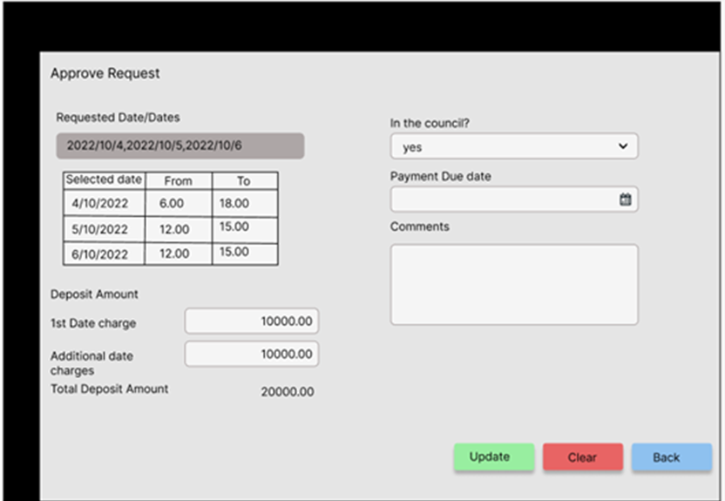

Figure 12- Update Payment